**Leader Overview**

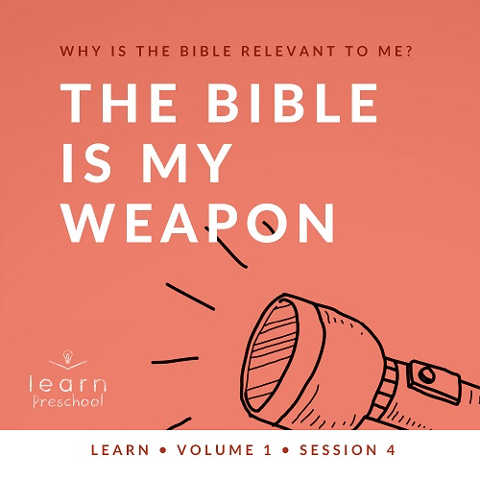

**Volume Overview**

**Why is the Bible relevant to me?**

*Our upbringing often influences our view of the Bible. In your home, was the Bible a dust-covered book that you thought kept people from having any fun? Was it honored as the living, breathing Word of God? Or did your childhood view of God’s Word fall somewhere in between? In this* **Learn** *volume, we want kids to know that God speaks through His Word to those who will listen, giving guidance and correction for their lives (*[*2 Timothy 3:16–17*](https://ref.ly/logosref/Bible.2Ti3.16-17)*).*

**The Bible Is My Weapon**

*In this* **Learn** *session, preschoolers will discover that the Bible has the power to help us win every fight against the devil, our enemy. Throughout the Bible, we see people use words from God to build up their faith and the faith of others. God’s Word also helps us to declare victory over our enemies. God has given us the gift of His Word to help us in every battle we face. Preschoolers will learn that they can use God’s Word to help them defeat the enemy.*

**Bible Lesson**

**Jesus Uses Scripture to Overcome Temptation**

[Luke 4:1–13](https://ref.ly/logosref/Bible.Lk4.1-13)

**Faith Fact**

I will use God’s Word.

**Faith Verse**

[2 Timothy 3:16](https://ref.ly/logosref/Bible.2Ti3.16)

All Scripture is inspired by God and is useful to teach us what is true.

**Preparing for the Session**

**Leader Preparation Time: 20–25 Minutes**

|  |
| --- |
| ***You Will Need***  ***Preservice Activities***   * *Pretzel sticks* * *Flat round cookies* * *Card stock* * ***Preservice Bible Story Cards*** * *Scissors*   ***Large Group***   * *Bible* * *Worship songs (Song suggestions: “Only a Boy Named David” by Bible Songs for Kids; “The Lord Is My Rock” by freedomkids; “Nothing Is Impossible” by Planetshakers Kids)* * *For groups not using a phone or tablet only, add:*   *• Projector or TV*  *• Laptop*  *•* ***Faith Fact Sound*** *video (bell ringing)*  *•* ***Faith Fact Slide***  *•* ***Faith Verse Slide***  *•* ***Bible Lesson Video A***  *•* ***Bible Lesson Video B***  ***Small Group***   * *Balloons, one per kid (consider using nonlatex balloons to avoid allergies)* * ***Small Group Activity Page****, one per kid* * *Crayons or markers* * *Three balls that roll easily* * *Large piece of white paper for each small group* * *White crayon* * *Watercolor paints and paintbrushes OR markers*   *To download session videos, slides, and printables, visit:*  [*BibleEngagementProject.com/downloads*](https://bibleengagementproject.com/Downloads) |
| ***Getting Ready***  ***Preservice Activities***   * *Set out toys and snacks.* * *Print the* ***Preservice Bible Story Cards*** *on card stock. Cut apart each card.*   ***Large Group***   * *Download videos and slides if needed.* * *Select worship song(s) and have them ready to play.*   ***Small Group***   * *Blow up and tie the balloons.* * *Print copies of the* ***Small Group Activity Page****, one per kid.* * *Write the Faith Verse on the large paper with a white crayon.*   ***First time leading* Learn *for Preschool? Check out the*** [***Facilitator Guide***](https://0b769b0ed3569ef9d18b-f88d8272f61086866d50d048b43ef630.ssl.cf2.rackcdn.com/sites/biblengagementproject/Listen_Facilitator_Guide.pdf)***.*** |

**Preservice Activities**

*See what’s needed at the beginning of the session.*

**Bible Story Warm-Up**

Today, we’re going to learn that we can use God’s Word to help us. The Bible is filled with so many promises from God. They tell us He loves us, that He will always be with us, and that He will take care of us. When we know God’s Word, we can know what to do and how to do it.

The best thing about God’s Word is that we can use it, too. When we know God’s Word and use it, God can help us do big things! It’s not always easy to do the right thing, is it? *(Group response)* When we know what’s right but want to do something wrong anyway, that’s called temptation. People in the Bible were tempted to do the wrong thing, too.

Here are some pictures that represent different Bible stories. These Bible stories show people who chose to do what God wanted them to. It probably wasn’t easy. Let’s see if we can figure out what they were tempted to do. You’ll take turns picking a card. Then, let’s see if we can figure out what they were tempted to do. We’ll help you out if you’re not sure what it is.

• *Have kids take turns picking a* ***Bible Story Card****.*

• *Ask these questions for each card:*

• Who is this Bible story picture about?

• What did he do right with God’s help?

• What might he have been tempted to do wrong?

It’s not always easy to do the right thing, but thankfully God gave us His Word to help us know what to do. When we use God’s Word, we can make the right choices! We’ll find out more about that in our Bible time today.

**Snack**

Swords and Shields (Pretzel sticks and round cookies)

• *As kids are eating the snack, share the following:*

Today we have some awesome snacks. I like to use my imagination, don’t you? *(Group response)* Our snacks look a lot like swords and shields*. (Make fighting sound effects.)* A sword and a shield are used to help soldiers in a battle. We don’t carry swords around, but we can use the Bible to help us. Did you know God’s Word calls the Bible a sword? *(Group response)* In today’s Bible story, we’re going to see how Jesus used the Bible to help Him.

What are ways you think the Bible can help you? *(Allow responses.)* The Bible helps us know how to do what is right.

**Free Play**

*Any extra time can be spent playing with toys.*

**Transition**

*A few minutes before service begins have kids make their way to the large group area and sit in their designated areas.*

**Large Group**

**25 Minutes**

*See what’s needed at the beginning of the session.*

**Introduction**

Friends, I’m so excited that you are here today! Are you excited to be here? *(Group response)* We have a super fun day planned that’s going to teach us about using God’s Word. That might sound a little silly to you. How can we use God’s Word? *(Allow responses*.) Those are some great ideas! When I say we use God’s Word, that really means to know it, follow what it says, and say it out loud. When we say God’s Word out loud, it might help our friends, it might help us to feel better, and it will remind everyone of how powerful God is.

**Faith Fact**

When we use God’s Word, we follow what it says. We know Bible verses and say them out loud. When we say God’s Word out loud, He will help us. That reminds everyone of how powerful God is. That’s why our Faith Fact today is **I will use God’s Word.**

• *Show the* ***Faith Fact Slide.***

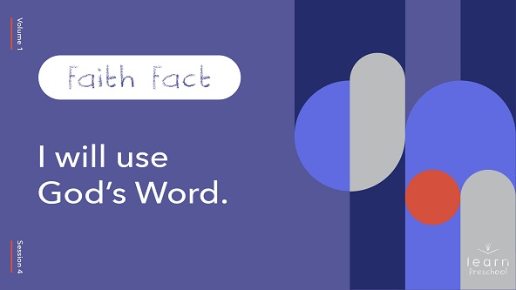

Let’s say our Faith Fact together. Pretend you have a sword in your hand. The first time we say it, let’s hold our sword in front of us. Ready? 1, 2, 3. **I will use God’s Word.** Awesome! This time let’s pretend to swing our sword with each word. Ready? 1, 2, 3. **I will use God’s Word.**

**Bible Time**

One of the most important things we do together is learn from God and His Word, the Bible. We’ve got someone special to help us do that. Let’s see what Lizzy is doing.

• *Play* ***Bible Lesson Video A****.*

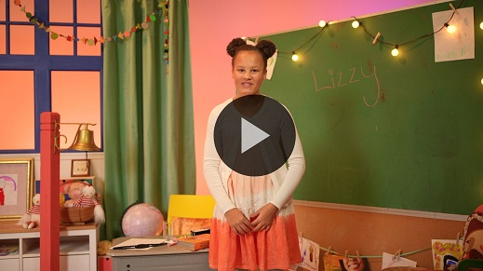

You’re doing a great job learning our Faith Verse. Did you know that one of the best ways to use God’s Word is to know it? That’s why we’re learning this Bible verse together.

**Worship**

Let’s spend some time worshipping and telling God thanks for giving us His Word, the Bible.

**Praise**

Are you glad God is here with us? Touch your toes down low. *(Group response)*

Are you glad God gave us His Word, the Bible? Clap your hands three times. *(Group response)*

Who wants to tell God I love you? Wave your hands up high. *(Group response)*

**Sing**

Another way we can worship is when we sing. When we sing, we aren’t just saying words, but we’re worshipping God. Worship is our time to tell God how much we love Him. Let’s focus on God as we worship Him and sing.

• *Lead the kids in singing one or two songs. See song suggestions at the beginning of the session.*

**Prayer**

I love when we get to worship together. I love hearing you tell Jesus how much you love Him. Now let’s pause and pray. Repeat this prayer after me.

|  |
| --- |
| Dear God, thank You for Your Word, the Bible. I can use it when times are good and when they are hard. Please help me to choose to do the right thing, especially when I’m tempted to do wrong things. I love You. Amen. |

**Bible Time cont’d**

Thanks for worshipping with me. Who’s ready to check back in with Lizzy? *(Group response)*

• *Play* ***Bible Lesson Video B.***

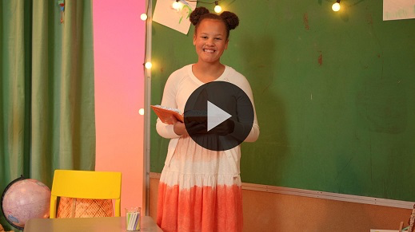

Wow! Lizzy learned so much about using God’s Word. Raise your hand if you enjoyed today’s Bible story. *(Group response)* I always love getting to learn more about Jesus’ life. Who tried to trick Jesus into doing something wrong? *(Allow responses.)* That’s right, the enemy did. The enemy is the devil. He didn’t want Jesus to do all the great things God had for Him, but Jesus fought back when He spoke the Word of God back to the devil. Jesus used Bible verses not only to fight but also to win that day.

**Response Time**

• *Play a worship song quietly.*

Today, our Bible story about Jesus showed us that God’s Word, the Bible, is very helpful. We can use God’s Word when the enemy wants us to do something wrong. When we use it, we can win! When we don’t know what to do, we can look in the Bible. When we want to do something we know we shouldn’t, we can remember Bible verses that will help us to make the right choice. When we want to remember how good God is, we know it’s true because of the Bible.

No matter what is happening in your life, you can always use the Bible to help you. Now, let’s pray.

• *Optional: Have the kids repeat phrases of the prayer after you.*

|  |
| --- |
| Dear God, thank You for the gift of Your Word, the Bible. Help me to learn it and use it. I love You. Amen. |

**Faith Verse**

The best way to use God’s Word is to know God’s Word, so let’s practice our Faith Verse with the actions.

• *Show the* ***Faith Verse Slide****.*



[2 Timothy 3:16](https://ref.ly/logosref/Bible.2Ti3.16)

All Scripture is inspired by God and is useful to teach us what is true.

**2 Timothy** *(hands at waist, spread apart, palms up and out)*

**3:** *(hands together like a clap)*

**16** *(hands opened to “book”)*

**All Scripture is inspired** *(hold out hands in front, palms up)*

**by God** *(point up)*

**and is useful to teach us** *(roll hands over each other)*

**what is true.** *(two thumbs up)*

You’re so awesome! You’ve done such a good job with our Faith Verse.

**Closing**

We have learned so much today. Who can tell me one thing you learned today*? (Allow responses.)* Woah! You’ve learned a lot today! I love that we can come together and learn more about God and His Word. This week let’s tell five people that we can use God’s Word.

• *Play the* ***Faith Fact Sound*** *video (bell ringing).*

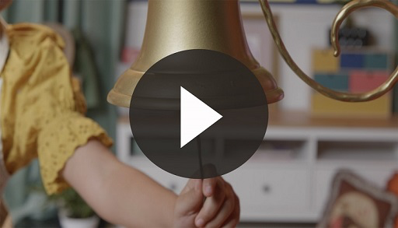

I love that sound. That sound means it’s time to say the Faith Fact.

• *Show the* ***Faith Fact Slide.***



Let’s shout it together. Ready? **I will use God’s Word.**

Wait! Before we go, let’s say our Faith Fact one more time. We’re going to put our hands up in the air like we just won a battle against our enemy. *(Demonstrate the action.)* Let’s say it as loud as we can. Ready? 1, 2, 3. **I will use God’s Word.**

**Dismissal to Small Groups**

Great job! Now let’s head to our circles and keep the fun going.

• *Dismiss the kids by groups.*

|  |
| --- |
| ***Leader Tip****: This can be done by assigning color teams or by age groups. Note that some young preschoolers may not know their age. Using a colored sticker, jersey, or wristband will help separate the kids and help identify their small groups.* |

**Small Group**

**25 Minutes**

*See supplies and prep instructions at beginning of session or in each activity below.*

|  |
| --- |
| ***Leader Tip****: Small groups can alternate to each circle, or all groups can do each activity at the same time. If you choose to alternate, you will need at least one leader per circle.* |

**Circle 1**

**Group Connection**

**Balloon Bounce**

|  |
| --- |
| ***You Will Need***  *• Balloons, one per kid (consider using nonlatex balloons to avoid allergies)*  ***Getting Ready***  *• Blow up and tie the balloons.* |

Who’s ready to play a fun game today? *(Group response)* Me too. I’ve got a challenge for you. The goal is to keep your balloon in the air. If your balloon touches the floor, then go help a friend keep their balloon up in the air. We’ll play until there is only one balloon left in the air.

• *Give each kid a balloon.*

• *Play until there is only one balloon left in the air.*

Wow! You’re really good at this game. Sometimes it was a little hard when you were playing by yourself, but then you started to work together. You helped each other keep the balloons up. When we use God’s Word, it helps us, but it can also help others, too. This game is such a good reminder and a great way to practice our Faith Fact.

• *During the activity, interrupt and practice the Faith Fact.* **I will use God’s Word.**

• *Play the* ***Faith Fact Sound*** *video****.*** *Review the Faith Fact even if you can’t play the sound.*



**Circle 2**

**Activity Page Time**

**Right or Wrong?**

|  |
| --- |
| ***You Will Need***  *•* ***Small Group Activity Page****, one per kid*  *• Crayons or markers*  ***Getting Ready***  *• Print copies of the* ***Small Group Activity Page****, one per kid.* |

Today, we’ve learned how Jesus used God’s Word to fight the enemy. Just like Jesus, we need to remember to obey God’s Word and choose to do what’s right.

• *Hand out the* ***Small Group Activity Page****.*

We’ve got four pictures of people in the Bible who had to decide what to do. If they obeyed God, circle the picture. If they didn’t make a good choice, put an *X* on the picture. Let’s see what each picture is about.

• *Read the description for each picture. Give kids time to mark each picture.*

• *Allow kids to color the pictures.*

We can follow what God wants us to do every day in our life too. Who knows where we find what God wants us to do? *(Group response)* That’s right. It’s in the Bible. This reminds me of our Faith Fact. Let’s all say it together. **I will use God’s Word.** Great job!

**Circle 3**

**Feet-to-Floor Game Time**

**I Will Use God’s Word**

|  |
| --- |
| ***You Will Need***  *• Three balls that roll easily*  *No prep needed for this activity.* |

In today’s Bible story, we learned how the enemy tried three times to get Jesus to do the wrong thing, but Jesus used Bible verses to beat the devil. In our game today, one person will be in the center of the circle with three balls that represent temptations. The person in the center of the circle will roll a ball and try to touch someone with the ball. If the temptation (ball) comes toward you, your job is to dodge it. If you get touched by the temptation, step out of the circle and do three jumping jacks while you say our Faith Fact: **I will use God’s Word.**

• *Have kids stand in a circle.*

• *Choose someone to be in the center to roll the balls.*

• *Take turns until each kid has a turn to roll the balls.*

**Circle 4**

**Hands-On Learning**

**God’s Word in Our Heart**

|  |
| --- |
| ***You Will Need***   * *Large piece of white paper for each small group* * *White crayon* * *Watercolor paints and paintbrushes OR markers*   ***Getting Ready***   * *Write the Faith Verse on the large paper with a white crayon.* |

This may look like a blank piece of paper, but let’s see what happens when we add some color to it.

• *Allow each kid to take turns adding color to the page until the verse is revealed.*

Look! There are words on the page. It says, “[2 Timothy 3:16](https://ref.ly/logosref/Bible.2Ti3.16) All Scripture is inspired by God and is useful to teach us what is true.” Hey! That’s our Faith Verse. Let’s all say it. Repeat after me. [2 Timothy 3:16](https://ref.ly/logosref/Bible.2Ti3.16) *(Kids repeat)* All Scripture is inspired *(Kids repeat)* by God *(Kids repeat)* and is useful to teach us *(Kids repeat)* what is true. *(Kids repeat)*

Raise your hand if you know every word of our Faith Verse by heart. *(Group response)* When we memorize God’s Word, it’s like we hide it away to remember later. Just like we couldn’t see the verse when we first looked at this paper, those memorized Scriptures are always in our heart to help us when we need them. Our Bible story said that Jesus remembered verses that He had learned when the enemy wanted Him to do wrong things. Like our Bible story, Jesus will help us to remember verses we’ve learned.

**Dismissal**

• *Play the* ***Faith Fact Sound*** *video (bell ringing)****.***



• *Show the* ***Faith Fact Slide.***



It’s almost time to go. Let’s say the Faith Fact together one last time. **I will use God’s Word**. Great job! I had a great time learning more about the Bible today with you. See you next time!

• *Send home the* ***Small Group Activity Page*** *with each kid.*

• *Optional: Send home balloons from Small Group activity.*

• *Remind parents that there are* ***Family Devotions*** *available on the app to do with their kid.*

• *Tell everyone the date and time for the next session.*

.